Asynchronous FIFO Design and Verification

1. Introduction
An asynchronous First-In-First-Out (FIFO) buffer is a digital design component used to reliably transfer data between two independent clock domains. In modern System-on-Chip architectures, subsystems frequently operate at unrelated clock frequencies and phases. Without proper synchronization, data exchange across these domains may lead to metastability, data corruption, or functional failures. This project presents the complete design and verification of an asynchronous FIFO implemented in SystemVerilog, including RTL architecture, verification methodology, assertion-based checking, functional coverage analysis, and waveform validation. The primary objective is to ensure functional correctness, robust operation under corner cases, and safe clock-domain crossing (CDC) behavior.

2. Design Objectives
The asynchronous FIFO design was developed with the following key objectives:
- Enable data transfer between independent read and write clock domains.
- Ensure metastability protection through synchronizer circuitry.
- Maintain correct FIFO ordering for stored and retrieved data.
- Generate accurate and glitch-free status indicators such as full and empty.
- Prevent overflow and underflow conditions under stress scenarios.
- Support parameterized width and depth for scalable reuse.
- Provide safe initialization and recovery using asynchronous reset.
These objectives ensure reliable functionality and structural compatibility across diverse digital subsystems.

3. FIFO Architecture Overview
The asynchronous FIFO architecture is constructed using independent clock-domain logic, memory storage, and pointer synchronization mechanisms.

3.1 Dual-Port Memory Array
A shared memory array allows simultaneous read and write operations from separate domains without structural conflict. The memory depth is determined by the address width, enabling power-of-two scalability.

3.2 Write Pointer Logic
Write operations occur exclusively on the rising edge of the write clock. The binary write pointer increments after successful writes and is subsequently converted into Gray code for synchronization into the read domain.

3.3 Read Pointer Logic
Read operations are driven by the read clock domain. The read pointer progresses only when the FIFO contains valid data. Similar to the write side, the binary pointer is converted into Gray code before cross-domain transfer.

3.4 Pointer Synchronization
Two-stage synchronizers prevent metastability when transferring Gray-coded pointers between clock domains. This ensures safe and deterministic pointer comparisons.

3.5 Full and Empty Flag Logic
Status flags are generated based on synchronized pointer comparisons. The FIFO indicates empty when the synchronized write pointer equals the local read pointer and full when the next write pointer matches the synchronized read pointer with most significant bits inverted.

4. Implementation Details
The RTL implementation follows a structured approach to ensure clean separation of functionality across domains and synthesis-friendly construction.

4.1 Parameterization
The FIFO supports configurable data width and address size, enabling automatic scaling of memory depth as a power of two. This improves reusability and integration across varying system requirements.

4.2 Reset Scheme
An asynchronous active-low reset initializes internal pointers and flags to known states. Although memory contents are not reset, they remain unused until valid writes occur. Reset release is handled synchronously within each domain to ensure safe pointer behavior.

4.3 Clock Independence
All logic is strictly partitioned between the write and read clock domains. No combinational logic bridges the domains, preventing timing hazards. Only Gray-coded pointers cross domains via dual-flop synchronizers.

4.4 Data Flow
Data is written when write enable is asserted and the FIFO is not full. The binary write pointer increments, is converted to Gray code, and synchronized to the read domain. Data is read when read enable is active and the FIFO is not empty. The read pointer updates similarly and synchronizes back into the write domain. Full and empty conditions are determined exclusively through pointer evaluation.

5. Verification Environment
A modular and self-checking verification environment was developed using SystemVerilog components integrated into the testbench.

5.1 Testbench Structure
The top-level testbench instantiates the FIFO, generates independent clocks, applies reset, and coordinates agent execution.

5.2 Write and Read Agents
Each agent consists of stimulus generation, bus functional modeling, and monitoring elements. The write agent manages data insertion, while the read agent manages data retrieval and observation.

5.3 Scoreboard Functionality
The scoreboard maintains a reference data model to validate ordering and correctness. It detects data loss, duplication, or sequence violations based on monitored transactions.

5.4 Inter-Agent Communication
Mailboxes are used for synchronized transaction flow between stimulus generators, monitors, and the scoreboard without timing dependencies.

6. Verification Features and Test Scenarios
Comprehensive functional validation was achieved through a structured set of test scenarios designed to expose normal and corner-case behavior.

6.1 Normal Operation
Sequential writes and reads confirm correct baseline FIFO behavior and ordering.

6.2 Overflow Attempt
Excessive writes beyond capacity ensure that the FIFO blocks additional writes and asserts full status without overwriting stored data.

6.3 Underflow Attempt
Reads performed when the FIFO is empty confirm that no invalid data is produced and that empty status is correctly maintained.

6.4 Concurrent Read and Write
Simultaneous operations across independent domains verify stable pointer progression and flag integrity under active traffic.

6.5 Pointer Wrap-Around
Extended operation ensures correct handling when pointers cycle through memory boundaries.

6.6 Reset Recovery
Assertions validate that the FIFO returns to a known empty state upon reset during active transactions.

7. Assertion-Based Verification
SystemVerilog Assertions were implemented to enforce protocol correctness and detect violations during simulation.

7.1 Key Assertion Properties
Assertions ensure that no write occurs when the FIFO is full, no read occurs when empty, and pointers remain stable during reset. These properties improve observability and accelerate functional issue detection.

7.2 Assertion Benefits
The use of assertions provides immediate feedback on protocol failures, enhances confidence in CDC safety, and supports automated failure reporting during regression.

8. Functional Coverage Analysis
Coverage metrics were employed to measure verification completeness and scenario execution.

8.1 Coverage Points
Coverage models track write and read enable events, empty and full transitions, pointer wrap-around, concurrent access, and illegal operation attempts.

8.2 Coverage Results
Simulation achieved full functional coverage, indicating that all planned verification scenarios were executed successfully.
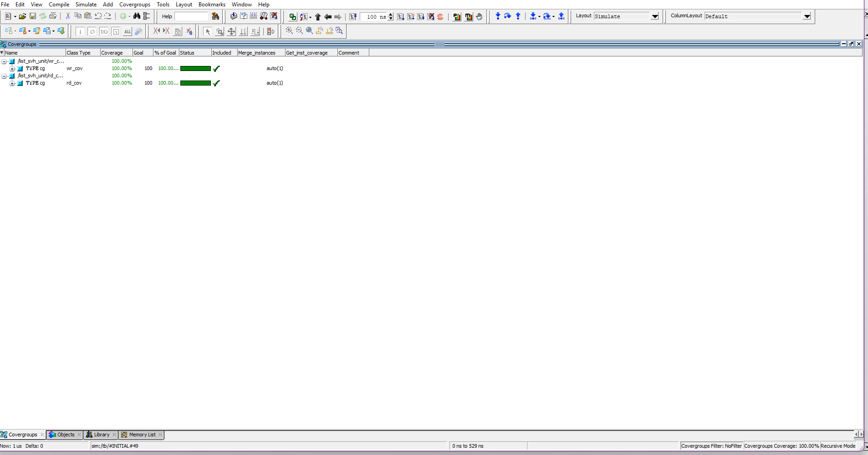
Fig. coverage report

9. Waveform Observation and Analysis
Waveform analysis confirmed correct signal behavior across all operational modes. Independent clock activity demonstrated stable pointer updates, proper flag transitions, and valid data movement. Reset-induced behavior returned the FIFO to an empty state as expected, and no data corruption was observed during concurrent read/write operations.
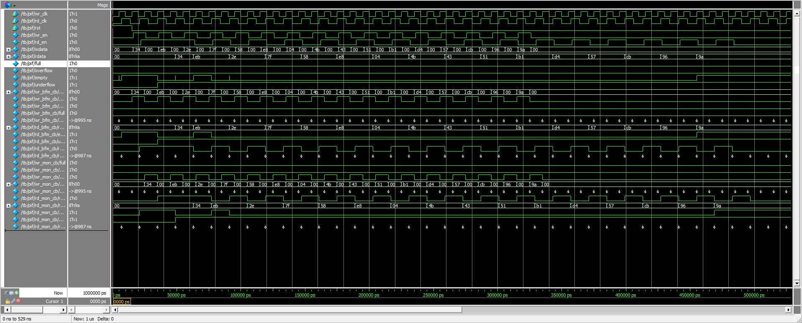
Fig. waveform

10. Conclusion
The asynchronous FIFO design meets all functional and CDC safety requirements. Verification through assertions, coverage-driven testing, and waveform analysis validated stable operation under normal and stress conditions. The implementation is suitable for integration into larger digital subsystems requiring reliable cross-domain communication.

11. Future Enhancements
Potential improvements include migration to a UVM-based environment, support for programmable threshold indicators, incorporation of error-detection mechanisms, and application of formal verification techniques for exhaustive correctness.

